Cyfeillion Cronfeydd Dŵr Caerdydd
Friends of Cardiff Reservoirs

INAUGURAL GENERAL MEETING
Tuesday 20 July 2021* @ 7pm
at
Lisvane & Llanishen Reservoirs
Entrance: off Lisvane Road

Prior to the start of the Meeting there will be a Site Induction/Health & Safety briefing by a Welsh Water staff member.
AGENDA

- Introduction by the Chairperson
- Adopt the draft Constitution by a ballot of Members
- Hold any necessary ballots and declare the election of members of the Executive Committee
- Appoint an Auditor
- Consider such other business as the Chair of the meeting may admit. No vote to be taken.
- Close of Inaugural Meeting

Following the meeting there will be an update by Welsh Water on the current situation regarding the development plans for the reservoir site and the volunteering opportunities planned for 2021 after which there will be an opportunity to ask questions regarding the site development, volunteering or the Friends group.

* In the event of exceptionally inclement weather being forecast for 20 July 2021 the meeting will be postponed to the 27 July 2021. A decision will be made and announced by email not later than Sunday 18 July 2021.

Please take note of the following:

- YOU MUST NOT ATTEND the meeting if you are showing any signs of Covid 19 symptoms or isolating.
- Lisvane & Llanishen is an operational site, with two reservoirs, currently closed to the public. The site has sensitive ecology with two SSSI (Site of Special Scientific Interest) designations and SINCs (Site of Importance for Nature and Conservation), which means access will be restricted / limited in certain areas. A site induction will be given on arrival and all parties must follow instructions for their own safety and the protection of the ecology.
- The meeting is only open to Members* (carers excepted) and Pre-Registration is required by email to treasurer@friendsofcardiffreservoirs.org not later than 17 July 2021 giving all names if in a group and how they will be travelling.
- The meeting will be in the open-air and attendees must bring their own seat.
- Weather appropriate clothing must be worn and all footwear will need to be enclosed with a grip.
- Car-parking on site is limited and members are requested not to travel by car if at all possible.
- When on the site please follow the directions of the stewards and please do not wander away from the meeting area.
- Social distancing must be observed at all times. Family groups may sit in close proximity but otherwise there should be a 2 metres space all round seats. Please fill up from the front and take the next available space.
- The entrance will be open from 6:00pm. Please try to arrive early to give time for registration to allow the meeting to start on time.

Entrance via Lisvane Road

- Lisvane Road, Cardiff. CF14 0EW
- Lane access is between South Rise and Crofta (entrance highlighted in yellow below).
- The lane also gives access to South Rise allotments; at the end of the lane, Welsh Water’s entrance is on the left.
- Registration of attendance will take place at the at Welsh Water gate entrance at the end of the lane (highlighted in green below). Only Members who have Pre-Registered will be admitted.
- At the entrance, each Member will be handed a voting slip for the Committee Elections. Please could you complete the slip before the meeting starts and deposit it in the box on the table at the front so that they can be counted

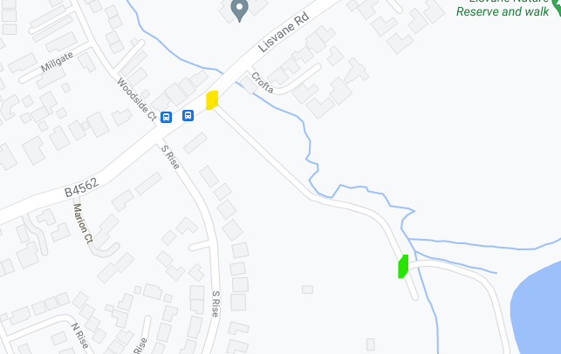

* You can apply for membership and Pre-register for the Inaugural General Meeting provided the Pre-registration is received by 17 July 2021. Membership applications can be made online or by downloading a form. See “Membership” tab in main menu.

